Fundamentals of Software Design Unit 4

David Finger

Colorado Technical University

Abstract

Define object classes for UML diagram. Show is-a relationship and has-a relationship. Show a sequence interaction diagram, a activity diagram, and a state diagram. Discuss changes made to the system.

OOD for UML component Diagrams:

1. UML component from unit 3:

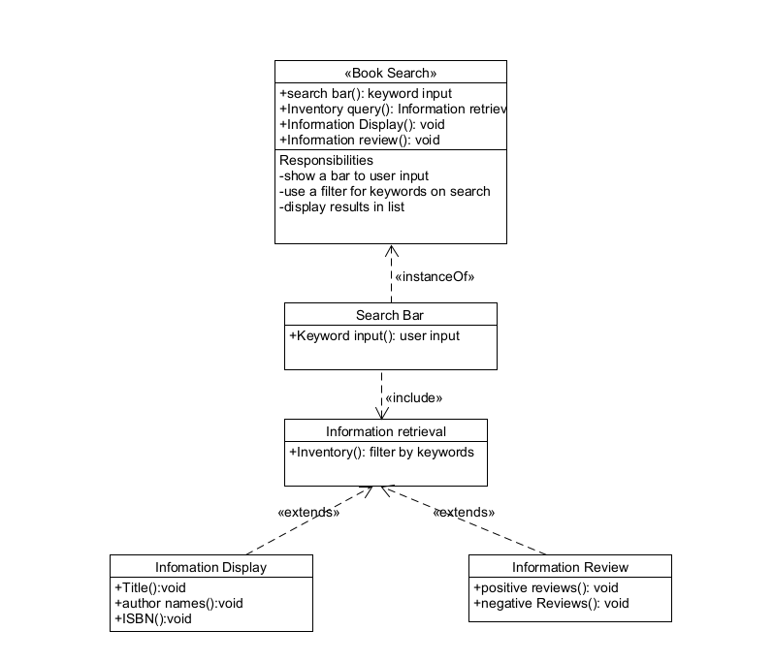

1. List of components and object classes
   1. Search Bar
      1. Search engine
      2. 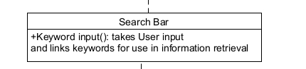
   2. Information Retrieval
      1. Website Interaction
      2. 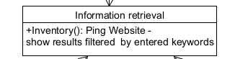
   3. Information Display
      1. Book
      2. 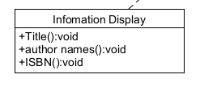
   4. Information Reviews
      1. Review
      2. 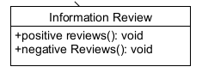
2. 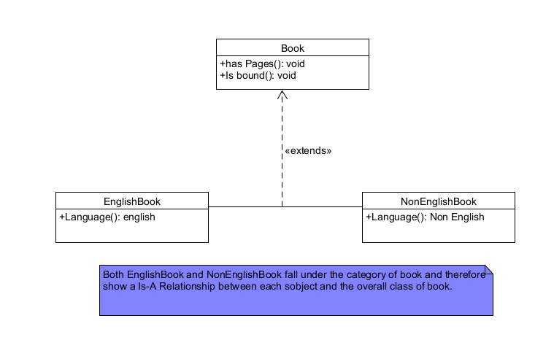Is-A Relationship Diagram:
3. Has-a relationship diagram:

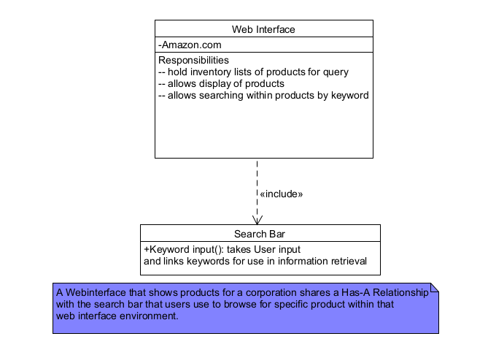

1. Diagram

   Description automatically generatedUML sequence diagram:
2. Graphical user interface, application

   Description automatically generatedClass: Text Search Engine, activity diagram:
3. Class: order, activity diagram:

1. Diagram

   Description automatically generatedClass: Search Engine, state diagram:
2. Text

   Description automatically generated with medium confidenceClass: Shopping Cart, State diagram:
3. Reduced the original component level design to only include a relative book searching feature instead of all products. Changes made to simplify the design and a similar process can be done for each sub-category available for search.

Resources